Custom Training

Day 23

**Azure Machine Learning**

Machine Learning: We train our models based on some data given to the machine.

Creation of Azure ML -> Creation of Compute Cluster

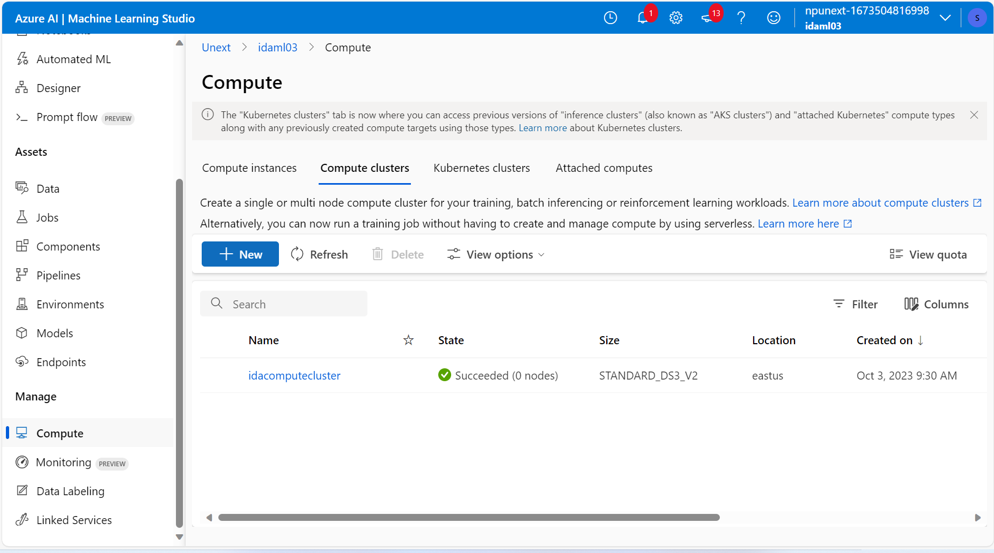

Types of ML Algorithms:

1. Supervised : Labelled data.
2. Unsupervised : Unlabelled data.
3. Semi-Supervised : Combination of above two. We take very less amount of labelled data and more amount of unlabelled data.
4. Reinforcement : Feedback based. Series of decision making based on action or feedback.

To choose an algorithm: We run our dataset on each algorithm and analyse the accuracy score. The highest accuracy scored algorithm is chosen.

Pipeline: We create pipeline to transform and run ML algorithms on the datasets.

